Your Personal Site Plan

1. Purpose and Audience
The purpose of this site is to serve as a "Portfolio of Process" for Jacob Farrow, a software engineering student. It is designed for potential employers, recruiters, and fellow developers. The site's goal is to showcase how Jacob solves problems by presenting projects as mini-case studies (detailing the problem, process, and challenges) rather than just a list of finished products.

2. Logo
The logo for the site is the provided modern, tech-themed hexagon:


3. Colors and Fonts
The color palette and fonts are based on the provided logo and design wireframe.
Category | Description
Primary | Dark Blue/Purple (from logo/cards)
Secondary | Medium Grey (text, e.g., "Class Projects")
Background | White (#FFFFFF)
Accent | Bright Blue (from button and logo elements)
Text | Dark Grey (for body copy)
Fonts | Headings: A clean, bold, sans-serif (e.g., Montserrat, Poppins)  Body: A highly-readable, standard sans-serif (e.g., Open Sans, Roboto)

4. Site Structure (Sitemap)
To meet the assignment requirements, the site will consist of a homepage and two child pages.
- Home (index.html): The main landing page and summary portal.
  - The "View My Work" button will link to the Projects page.
  - The "About Me" link in the navigation will link to the About Me page.
- Projects (projects.html): Child Page 1. This page will host the full gallery of project case studies.
- About Me (about.html): Child Page 2. This page will contain the detailed biography, skills table, downloadable resume, and contact form.

5. Wireframes
The site requires two wireframes: one for the homepage and a template for the child pages.
A. Homepage Wireframe
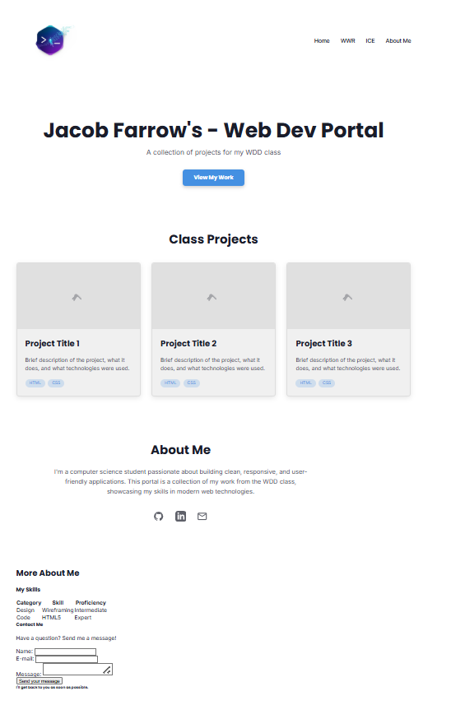

B. Child Page Wireframe (Template)
This layout will be used for the About Me page. It reuses components from the homepage in a dedicated space.
Child Page Wireframe: "About Me"
- Header: Logo (left) | Navigation (Home, Projects, About Me) (right)
- Page Title: <h1> - "About Me"
- Two-Column Layout:
  - Left Column :
    - <h2> - "My Story" (Detailed bio)
    - <h2> - "My Skills" (The "My Skills" table)
  - Right Column :
    - Button: "Download My Resume"
    - <h2> - "Contact Me" (The "Send me a message" contact form)
- Footer: Copyright | Social Media Links (GitHub, LinkedIn)

6. Content Plan
This section outlines the specific text and media needed for each page.

Homepage (index.html)
- Headline: Jacob Farrow's - Web Dev Portal
- Sub-headline: A collection of projects for my WDD class
- Button Text: View My Work
- Section Title 1: Class Projects
- Project 1 Card:
  - Image: [Screenshot of Project 1]
  - Title: [Project 1 Title]
  - Description: [Brief description of the project, what it does, and technologies used.]
- Project 2 Card:
  - Image: [Screenshot of Project 2]
  - Title: [Project 2 Title]
  - Description: [Brief description...]
- Project 3 Card:
  - Image: [Screenshot of Project 3]
  - Title: [Project 3 Title]
  - Description: [Brief description...]
- Section Title 2: About Me
- About Me Blurb: [I'm a computer science student passionate about building clean, responsive, and user-friendly applications...]

Child Page 1: Projects (projects.html)
- Page Title: My Projects & Case Studies
- (For each project, the following case-study is needed)
- Project 1: [Project Title]
  - The Problem: [1-2 sentences about the goal. What problem were you solving?]
  - My Process: [1-2 paragraphs about how you built it. What steps did you take?]
  - The Challenges: [1 paragraph about a bug you fixed or a challenge you overcame.]
  - Tech Used: [List of tech: e.g., HTML, CSS, JavaScript]
  - Links: [Link to GitHub repo] | [Link to live site (if available)]
- Project 2: [Project Title]
  - The Problem: [...]
  - My Process: [...]
  - The Challenges: [...]
  - Links: [...]

Child Page 2: About Me (about.html)
- Page Title: About Me
- Detailed Bio: [Expand on homepage blurb. Talk about passion for software, goals, and what being learnt.]
- Resume: [A PDF file of your resume will be needed for the "Download Resume" button.]
- Skills Table: [List of skills, categories, and proficiency.]
- Contact Form

